Terrific Tales for Tweens
Book Club
Grades 6-8

Thursday, September 1, 2022 at 3:30 P.M. | Organizational Meeting  If you cannot make it and are interested in the Book Club, please call Evelyn at (906)875-3344 to register. | A quick meeting to briefly discuss the club and determine what would be a good day/time for our meetings.

Date and Time | Title of Book | Description of the Book  (taken from Wild + Free Book Club) | Activities
 | Mrs. Frisby and the Rats of Nimh  by Robert C. O’Brien  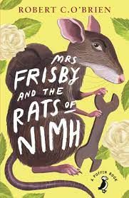 | Mrs. Frisby and the Rats of NIMH, winner of the 1972 Newbery Medal, tells the tale of a widowed field mouse, Mrs. Frisby, who finds her family in desperate danger and seeks the aid of a local colony of uniquely intelligent rats who have an incredible and intriguing history. Mrs. Frisby soon finds herself caught up in adventure, daring acts, and strong kinship with the rats. | *book discussion  *playing The Nimh Name Game  *making a mouse craft  *enjoy a cheese board, trail-mix bar, and dirt cake!
 | Roll of Thunder, Hear My Cry  by Mildred D. Taylor  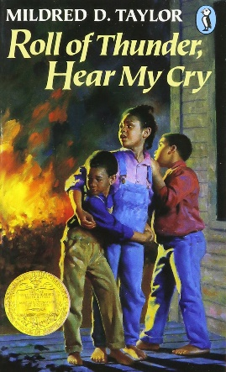 | The book, which follows a Black Family’s life in rural Mississippi during the Great Depression, does not shy away from the hard realities of racism, segregation, Jim Crow, and even lynching. The story line is honest and does not hold back, but nothing is shared for shock value; it is all necessary to the plot. The book also delves deeply into themes of family, community, friendship, and education. | *book discussion  *building community food baskets  *making wreath ornaments  *creating fables  *enjoying Southern foods
 | The Crossover  by Kwame Alexander | The subject of much of the book is basketball, which seamlessly weaves this novel in verse together. Another heavier topic in the novel is heart health. Readers will emerge with a new understanding of brotherhood, friendship, family, and life. | *book discussion  *playing Crossover Dribble  *writing concrete poetry  *learning the Cha-Cha Slide  *enjoying food mentioned in the novel
 | Little Women  by Louisa May Alcott  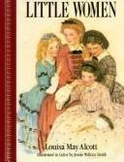 | Little Women is a lovely coming-of-age story that the author based on her own life. It is filled with the rich values of family, loyalty, patience, generosity, modesty, and hard work. Although this book is about four sisters, you can be sure everyone will enjoy it. | *book discussion  *playing Rigmarole  *Preparing and eating Amy’s Pickled Limes
 | Around the World in Eighty Days  by Jules Verne  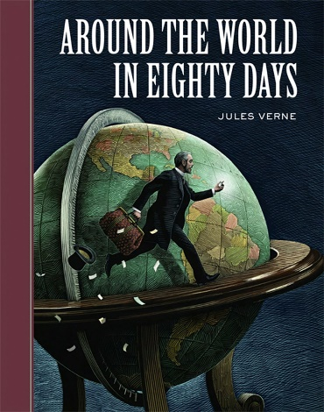 | The story follows two travelers that grow to a trio and then a foursome as they fight their way through countless obstacles to reach home. The main characters are Phileas Fogg who is trying to win a bet that he made with the Reform Club that he can travel around the world in 80 days. | *book discussion  *station hopping from England to Egypt to India to China to Japan to the U.S.A.  *trying foods from all six countries
 | Treasure Island  by Robert Louis Stevenson  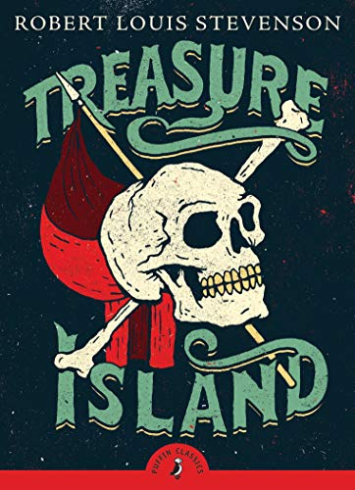 | Published in 1883, Treasure Island is one of the most highly read adventure novels of all time. The story provokes consideration of moral dilemmas and challenges us to explore good and evil as buccaneers take us on an unforgettable journey to find buried treasure. | *book discussion  *going on a treasure hunt  *shooting off cannons  *eating Pirate food

